Abstract Title

¹ Presenting Author, ² Author 2, …

¹ Affiliation 1 (Università or Industria, address).
² Affiliation 2
(presentingauthor@address.ab)

Abstract has to be prepared in english.
Oral and Flash communications will be presented in Italian (exception for non-native speakers). Posters will be prepared in english as well.

Authors are fully responsible for the correct layout and content. The text of an abstract must be written in English. Graphics, figures, diagrams and tables should be placed in the same order as they appear in the paper, according to the template given (see Below). Abstracts must be received by September 28th, 2024. Bibliographic references (Times New Roman 10 pt font) should be given as footnotes, such as , and the references themselves should be placed according to the template indicated (see Below)

IMPORTANTE: Salvare il documento come COGNOME Nome_Tipo di Comunicazione (es. ROSSI Mario_Oral)

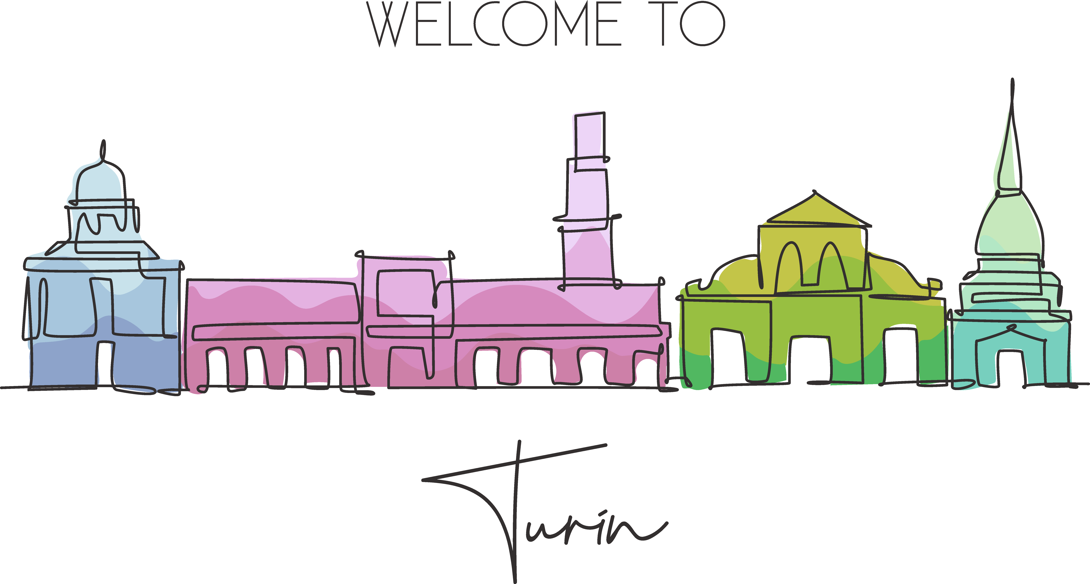
Figure 1. Didascalia

Tutti i margini (sopra, sotto, sinistra, destra) vanno impostati a 2.0 cm

Acknowledgements.

References: ? XXXX, X.; YYYYYY, Y. J. Med. Chem. 2002, 12, 6500-6521.

